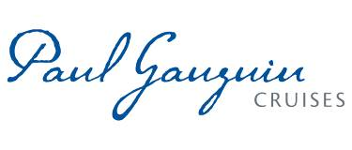
PAUL GAUGUIN CRUISES OFFERS FREE HOTEL OVERNIGHT IN EXOTIC SINGAPORE ON
2014 AUSTRALIA & SOUTHEAST ASIA VOYAGES

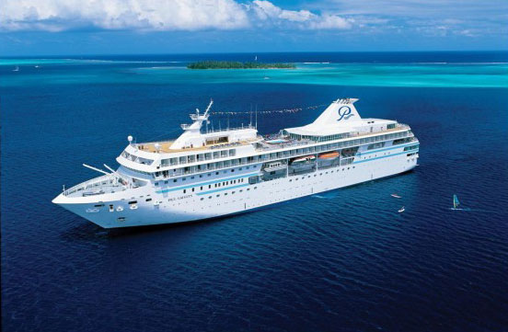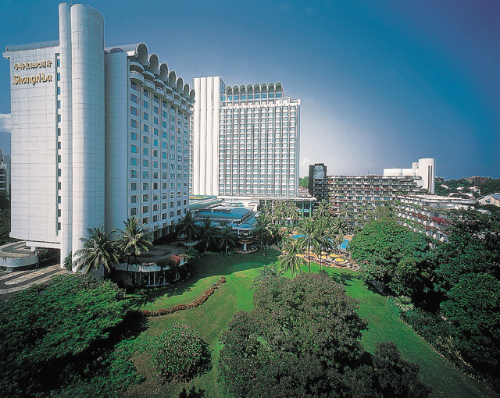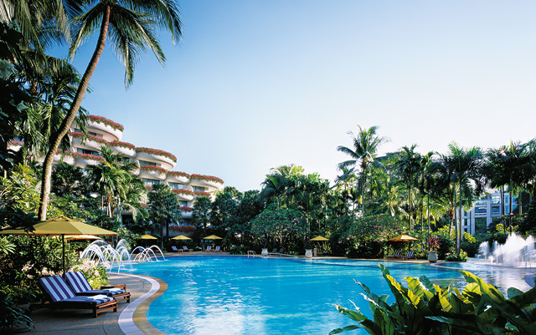
BELLEVUE, Wash. – October 23, 2013 – Paul Gauguin Cruises (www.pgcruises.com), operator of the highest-rated and longest continually sailing luxury cruise ship in the South Pacific, the m/s Paul Gauguin, and the 90-guest m/v Tere Moana, offers a free hotel overnight at the Shangri-La Hotel Singapore for guests who book one of The Gauguin’s 2014 14-night Australia & Southeast Asia voyages by December 31, 2013.
Set amid lush tropical gardens, the Deluxe Shangri-La Hotel is located in the heart of Singapore offering luxurious amenities, as well as easy access to the city’s world-class shopping, restaurants, and attractions. Overnight accommodations in a Tower Room, breakfast, transfers, and a guided city tour highlighting the Raffles Hotel, Little India, Arab Street, Merlion Park and Marina Bay, and Chinatown, are included with the free hotel overnight offer.

On the Australia & Southeast Asia voyages, The Gauguin sails between Cairns, Australia, and Singapore visiting less-traveled tropical ports of Australia such as Thursday Island, once a World War II military outpost, and Darwin, with its lively yet laidback ambiance. Indonesian ports include Komodo Island, home of the Komodo dragon; beautiful Bali, a coveted destination for generations; and Semarang, with its fascinating history and gateway to the temples of Borobudur. In addition to the free hotel overnight offer, guests save 50% off standard all-inclusive cruise fares and enjoy included airfare from Los Angeles. Cruise fares for the June 25, 2014, sailing start from $7,395 per person and cruise fares for the August 4, 2014, sailing start from $7,095 per person.

On both voyages, a variety of special guests will lecture, perform, or provide demonstrations. Parisian celebrity chef Jean-Pierre Vigato, champion freediver Herbert Nitsch, and extreme artist Jean Francois Detaille will be aboard the June 25, 2014, voyage. Joining the August 4, 2014, voyage are Nobel Peace Prize winner John E. Hay, islands expert Helen Henry, and Paul Gauguin Cruises chairman Richard Bailey. Art history professor and Paul Gauguin expert Caroline Boyle-Turner will lecture on both sailings.

For rates or more information on Paul Gauguin Cruises, please contact a Travel Professional, call 800-848-6172, or visit www.pgcruises.com.

###
About Paul Gauguin Cruises
Owned by Pacific Beachcomber S.C., French Polynesia’s leading luxury hotel and cruise operator, Paul Gauguin Cruises operates the 5+-star cruise ship, the 332-guest m/s Paul Gauguin, providing a deluxe cruise experience tailored to the unparalleled wonders of Tahiti, French Polynesia, the South Pacific, and Southeast Asia. It is one of the top exclusive charter and incentive group venues in the industry and has completed more than 570 South Pacific cruises, serving more than 176,250 guests, including more than 15,000 honeymooners, since its inaugural sail in 1998. The Gauguin’s accolades include recognition as “Top Small-Ship Cruise Line for Families” in Travel + Leisure’s 2013 “World’s Best Awards” and one of the “Top 20 Small Cruise Ships” in 2013 for the 15th year in a row by readers of Condé Nast Traveler.

In December 2012, the m/v Tere Moana began sailing under the Paul Gauguin Cruises banner after completing a multifaceted renovation and offers voyages in the Caribbean, Latin America, and Europe. At 330 feet long and 46 feet wide, The Moana has a draft of 11.5 feet, and accommodates 90 guests with a staff of 60.

Media Contact:
Vanessa Bloy
Paul Gauguin Cruises
Director of Public Relations
(425) 440-6255
vbloy@pgcruises.com

*Free hotel overnight offer available only while space lasts. New bookings only. Cruise prices shown do not include port, security, and handling fees of $225 per person. Economy class airfare from Los Angeles included in cruise fare. One-night pre- or post-cruise hotel offer applies to Air/Sea packages only, is capacity controlled, and can be withdrawn at any time. Hotel offer does not include meals other than those indicated, international, and domestic airfares, and items of a personal nature, such as alcoholic beverages, telephone calls, and laundry, etc. Hotel rating is based on www.hotelandtravelindex.com classifications. Offer expires December 31, 2013.

