
PAUL GAUGUIN CRUISES OFFERS EXCLUSIVE 2-WEEK SALE ON SELECT 2013
TAHITI, FRENCH POLYNESIA & SOUTH PACIFIC VOYAGES AND EUROPEAN SAILINGS

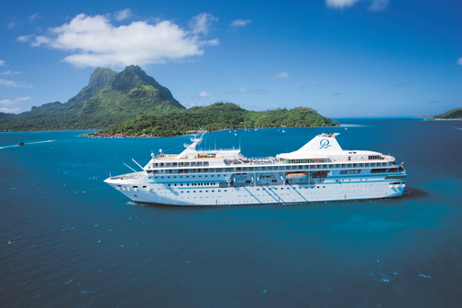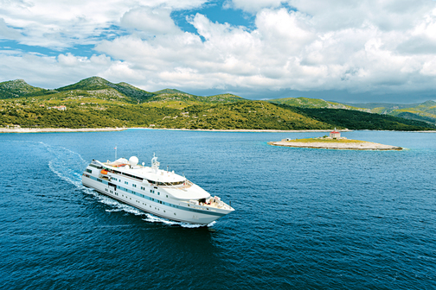

MEDIA ALERT: For two weeks only, Paul Gauguin Cruises, operator of the highest-rated and longest continually sailing luxury cruise ship in the South Pacific, the m/s Paul Gauguin, and the m/v Tere Moana, is offering incredible savings on select 2013 Tahiti, French Polynesia & South Pacific voyages and European sailings when booked between April 29 and May 11, 2013. Guests will benefit from exceptional savings of $850 to $2,550 per person off previously advertised rates while enjoying the highest standards of luxury, quality, and service in enchanting destinations.

Sale: Book select 7-night Tahiti & the Society Islands or 7-night European voyages and save $850 to $2,550 per person in addition to 50% off standard cruise fares on both ships with included airfare from Los Angeles on Tahiti, French Polynesia & South Pacific itineraries.

Tahiti & the Society Islands  7-night voyages: September 7, 14; October 12, 19, 26, 2013  Now from only $4,795 $3,945 per person  7-night voyages: July 13, 27; August 3, 10, 2013  Now from only $4,895 $4,045 per person | European Voyages  7-night voyage: Istanbul to Athens (Piraeus):  July 27, 2013  Now from only $3,595 $2,695 per person  7-night voyages: Athens (Piraeus) to Rome (Civitavecchia): June 15; September 21, 2013  Now from only $3,795 $2,845 per person

CONTACT: For more information or reservations, contact a professional travel agent, call 1-800-848-6172, or visit www.pgcruises.com.
###
About Paul Gauguin Cruises
Owned by Pacific Beachcomber S.C., French Polynesia’s leading luxury hotel and cruise operator, Paul Gauguin Cruises operates the 5+-star cruise ship m/s Paul Gauguin, providing a deluxe cruise experience tailored to the unparalleled wonders of Tahiti, French Polynesia, the South Pacific, and Southeast Asia. The ship, 513 feet long and 71 feet wide, has a draft of 16.9 feet, and can accommodate 332 guests with a staff of 217. It is one of the top exclusive charter and incentive group venues in the industry and has completed more than 570 South Pacific cruises, serving more than 176,250 guests, including more than 15,000 honeymooners, since its inaugural sail in 1998. The Gauguin received second place for small-ship cruise lines in Travel + Leisure’s “2012 World’s Best Awards” and was recognized as one of the “Top 20 Small Cruise Ships” in 2013 for the 15th year in a row by readers of Condé Nast Traveler.

In December 2012, the m/v Tere Moana began sailing under the Paul Gauguin Cruises banner after completing a multifaceted renovation and offers voyages in the Caribbean, Latin America, and Europe. At 330 feet long and 46 feet wide, The Moana has a draft of 11.5 feet, and accommodates 90 guests with a staff of 60.

Media Contact:
Paul Gauguin Cruises
Vanessa Bloy, Director of Public Relations
(425) 440-6255
vbloy@pgcruises.com

*Prices shown reflect savings and are per person based on double occupancy and in US dollars. Select sailings and new bookings only. Available only while space lasts. Offer may be combined with free 3rd guest in stateroom offer and applicable Paul Gauguin Society savings. Port, security, and handling charges of $89-$350 per person are not included. Offer expires May 11, 2013. Call for details. For full terms and conditions visit www.pgcruises.com.

