
PAUL GAUGUIN CRUISES OFFERS EXCLUSIVE 2-WEEK SALE ON SELECT 2013
TAHITI, FRENCH POLYNESIA & SOUTH PACIFIC VOYAGES AND EUROPEAN SAILINGS

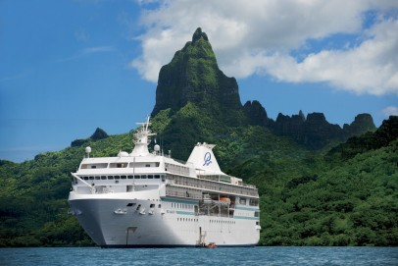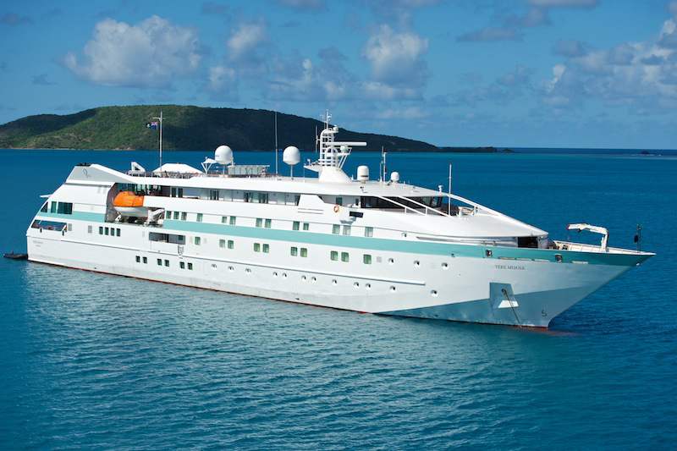

MEDIA ALERT: For two weeks only, Paul Gauguin Cruises, operator of the highest-rated and longest continually sailing luxury cruise ship in the South Pacific, the m/s Paul Gauguin, and its new ship, the m/v Tere Moana, is offering incredible savings on select 2013 Tahiti, French Polynesia & South Pacific voyages and European sailings when booked between February 18 and March 2, 2013. Guests will benefit from exceptional savings of $700 to $4,350 per person off previously advertised rates while enjoying the highest standards of luxury, quality, and service in enchanting destinations.

Sale: Book select 7-night Tahiti & the Society Islands, 14-night Marquesas, Tuamotus & Society Islands, or 7-night European voyages and save $700 to $4,350 per person in addition to 50% off standard cruise fares on both ships and receive included airfare from Los Angeles on Tahiti, French Polynesia & South Pacific itineraries.

Tahiti & the Society Islands  7-night voyages: May 4, 11, 2013  Now from only $4,595 $3,795 per person  7-night voyages: June 1, 8, 2013  Now from only $4,795 $3,945 per person  7-night voyages: July 6, 13, 2013  Now from only $4,895 $4,045 per person  Marquesas, Tuamotus & Society Islands  14-night voyage: May 18, 2013  Now from only $6,445 $5,195 per person | European Voyages  7-night voyage: Barcelona to Rome: April 20, 2013  Now from only $2,895 $2,195 per person  7-night voyage: Rome to Venice: May 11, 2013  Now from only $3,595 $2,695 per person  7-night voyages: Athens to Istanbul (or reverse): May 25 and June 8, 2013  Now from only $3,795 $2,845 per person  7-night voyage: Athens to Rome: June 15, 2013  Now from only $3,795 $2,845 per person

CONTACT: For more information or reservations, contact a professional travel agent, call 1-800-848-6172, or visit www.pgcruises.com.
###
About Paul Gauguin Cruises
Owned by Pacific Beachcomber S.C., French Polynesia’s leading luxury hotel and cruise operator, Paul Gauguin Cruises operates the 5+-star cruise ship m/s Paul Gauguin, providing a deluxe cruise experience tailored to the unparalleled wonders of Tahiti, French Polynesia, the South Pacific, and Southeast Asia. The ship, 513 feet long and 71 feet wide, has a draft of 16.9 feet, and can accommodate 332 guests with a staff of 217. It is one of the top exclusive charter and incentive group venues in the industry and has completed more than 570 South Pacific cruises, serving more than 176,250 guests, including more than 15,000 honeymooners, since its inaugural sail in 1998. The Gauguin received second place for small-ship cruise lines in Travel + Leisure’s “2012 World’s Best Awards” and was recognized as one of the “Top 20 Small Cruise Ships” in 2013 for the 15th year in a row by readers of Condé Nast Traveler in 2013.

In December 2012, the m/v Tere Moana began sailing under the Paul Gauguin Cruises banner after completing a multifaceted renovation and offers voyages in the Caribbean, Latin America, and Europe. At 330 feet long and 46 feet wide, The Moana has a draft of 11.5 feet, and accommodates 90 guests with a staff of 60.

Media Contact:
Paul Gauguin Cruises
Vanessa Bloy, Director of Public Relations
(425) 440-6255
vbloy@pgcruises.com

*Select sailings and new bookings only. Available only while space lasts. Offer may be combined with free 3rd guest in stateroom offer and Paul Gauguin Society savings. Offer expires March 2, 2013. Prices shown reflect savings. All fares and offers are per person based on double occupancy. Port, security, and handling fees of $89-$350 per person are not included. Call for details. For full terms and conditions visit www.pgcruises.com.

