
PAUL GAUGUIN CRUISES OFFERS EXCLUSIVE 2-WEEK SALE ON SELECT 2013 AND 2014
TAHITI, FRENCH POLYNESIA & SOUTH PACIFIC VOYAGES AND CARIBBEAN SAILINGS

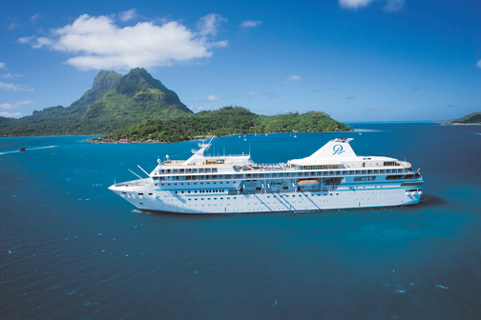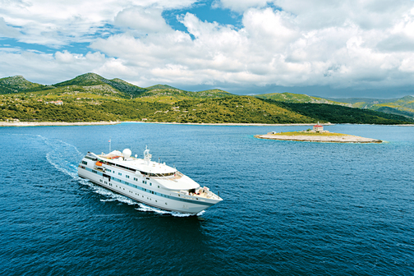

MEDIA ALERT: For two weeks only, Paul Gauguin Cruises, operator of the highest-rated and longest continually sailing luxury cruise ship in the South Pacific, the m/s Paul Gauguin, and the m/v Tere Moana, is offering incredible savings on select 2013 and 2014 Tahiti, French Polynesia & South Pacific voyages and Caribbean sailings when booked between July 15 and July 27, 2013. Guests will benefit from exceptional savings of $650 to $4,400 per person off previously advertised rates while enjoying the highest standards of luxury, quality, and service in enchanting destinations.

Sale: Book select 7-night Tahiti & the Society Islands; 10-night Society Islands & Tuamotus; 11-night Cook Islands & Society Islands; 14-night Marquesas, Tuamotus & Society Islands; and 7-night Roundtrip Philipsburg, St. Maarten voyages and save $650 to $4,400 per person in addition to 50% off standard cruise fares on both ships with included airfare from Los Angeles on itineraries aboard The Gauguin.

Tahiti & the Society Islands  7-night voyages: October 12, 19, 26; December 7, 14, and 21, 2013  Now from only $3,995 $3,345 per person | Society Islands & Tuamotus  10-night voyage: November 13, 2013  Now from only $4,995 $4,095 per person
Cook Islands & Society Islands  11-night voyage: January 25, 2014  Now from only $5,495 $4,495 per person | Marquesas, Tuamotus & Society Islands  14-night voyage: January 4, 2014  Now from only $6,595 $5,345 per person
Roundtrip Philipsburg, St. Maarten

7-night voyages: December 7, 14, and 21, 2013
Now from only $2,595 $1,945 per person

CONTACT: For more information or reservations, contact a professional travel agent, call 1-800-848-6172, or visit www.pgcruises.com.
###
About Paul Gauguin Cruises
Owned by Pacific Beachcomber S.C., French Polynesia’s leading luxury hotel and cruise operator, Paul Gauguin Cruises operates the 5+-star cruise ship m/s Paul Gauguin, providing a deluxe cruise experience tailored to the unparalleled wonders of Tahiti, French Polynesia, the South Pacific, and Southeast Asia. The ship, 513 feet long and 71 feet wide, has a draft of 16.9 feet, and can accommodate 332 guests with a staff of 217. It is one of the top exclusive charter and incentive group venues in the industry and has completed more than 570 South Pacific cruises, serving more than 176,250 guests, including more than 15,000 honeymooners, since its inaugural sail in 1998. The Gauguin’s accolades include recognition as a “Top Small-Ship Cruise Line” in Travel + Leisure’s 2013 “World’s Best Awards” and one of the “Top 20 Small Cruise Ships” in 2013 for the 15th year in a row by readers of Condé Nast Traveler.

In December 2012, the m/v Tere Moana began sailing under the Paul Gauguin Cruises banner after completing a multifaceted renovation and offers voyages in the Caribbean, Latin America, and Europe. At 330 feet long and 46 feet wide, The Moana has a draft of 11.5 feet, and accommodates 90 guests with a staff of 60.

Media Contact:
Paul Gauguin Cruises
Vanessa Bloy, Director of Public Relations
(425) 440-6255
vbloy@pgcruises.com

*Prices shown reflect savings and are per person based on double occupancy and in US dollars. Select sailings and new bookings only. Available only while space lasts. Offer may be combined with free 3rd guest in stateroom offer and applicable Paul Gauguin Society savings. Port, security, and handling charges of $89-$280 per person are not included. Offer expires July 27, 2013. Call for details. For full terms and conditions visit www.pgcruises.com.

