
PAUL GAUGUIN CRUISES OFFERS HOLIDAY SALE ON SELECT 2014
TAHITI, FRENCH POLYNESIA, SOUTH PACIFIC & SOUTHEAST ASIA VOYAGES, CARIBBEAN & EUROPEAN SAILINGS

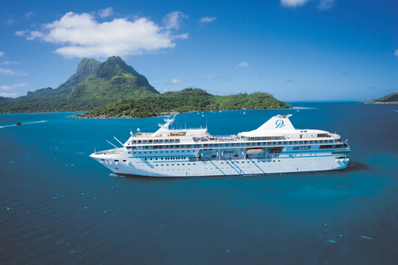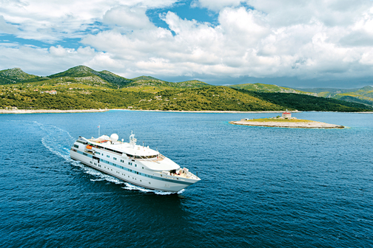

MEDIA ALERT: For two weeks only, Paul Gauguin Cruises, operator of the highest-rated and longest continually sailing luxury cruise ship in the South Pacific, the m/s Paul Gauguin, and the 90-guest m/v Tere Moana, is offering incredible savings on select 2014 Tahiti, French Polynesia, South Pacific & Southeast Asia voyages aboard The Gauguin, and Caribbean & European sailings aboard The Moana, when booked between November 29 and December 14, 2013. Guests will benefit from exceptional savings of $800 to $4,500 per person off previously advertised rates while enjoying the highest standards of luxury, quality, and service in enchanting destinations.

Sale: Book select 7-night Tahiti & the Society Islands; 11-night Cook Islands & Society Islands; 14-night Marquesas, Tuamotus & Society Islands; 14-night Australia & Southeast Asia; 7-night Colón, Panama, to Philipsburg, St. Maarten; 7-night Roundtrip Philipsburg, St. Maarten; 7-night Roundtrip Rome (Civitavecchia), Italy; 7-night Rome (Civitavecchia), Italy, to Venice, Italy; 7-night Athens, Greece, to Istanbul, Turkey; and 7-night Istanbul, Turkey, to Athens, Greece, voyages and save $800 to $4,500 per person in addition to 50% off standard cruise fares on both ships with included airfare from Los Angeles on itineraries aboard The Gauguin.

BLACK FRIDAY BONUS: Guests who book Holiday Sale voyages on Black Friday (November 29) or Saturday, November 30, 2013, will receive a bonus of $100 per-person Shipboard Credit to apply toward a service at the onboard spa, shore excursion, souvenir at La Boutique, and more.

Aboard The Gauguin | Aboard The Moana
Marquesas, Tuamotus & Society Islands  14-night voyage: January 4, 2014  Now from only $6,595 $5,345 per person | Colón, Panama, to Philipsburg, St. Maarten  7-night voyage: March 15, 2014  Now from only $2,995 $2,195 per person
Cook Islands & Society Islands  11-night voyage: January 25, 2014  Now from only $5,495 $4,495 per person | Roundtrip Philipsburg, St. Maarten  7-night voyage: March 22, 2014  Now from only $2,995 $2,195 per person
Tahiti & the Society Islands  7-night voyages: March 29; April 5, 2014  Now from only $4,895 $3,995 per person | Roundtrip Rome (Civitavecchia), Italy  7-night voyage: April 26, 2014  Now from only $3,795 $2,845 per person
Marquesas, Tuamotus & Society Islands  14-night voyage: April 12, 2014  Now from only $6,795 $5,495 per person | Rome (Civitavecchia), Italy, to Venice, Italy  7-night voyage: May 3, 2014  Now from only $3,795 $2,845 per person
Australia & Southeast Asia  14-night voyage: June 25, 2014  Now from only $7,395 $5,995 per person | Athens, Greece, to Istanbul, Turkey  7-night voyages: May 31, 2014; or  June 14, 2014 (reverse itinerary)  Now from only $3,995 $2,995 per person

CONTACT: For more information or reservations, contact a professional travel agent, call 1-800-848-6172, or visit www.pgcruises.com.
###
About Paul Gauguin Cruises
Owned by Pacific Beachcomber S.C., French Polynesia’s leading luxury hotel and cruise operator, Paul Gauguin Cruises operates the 5+-star cruise ship, the 332-guest m/s Paul Gauguin, providing a deluxe cruise experience tailored to the unparalleled wonders of Tahiti, French Polynesia, the South Pacific, and Southeast Asia. It is one of the top exclusive charter and incentive group venues in the industry and has completed more than 570 South Pacific cruises, serving more than 176,250 guests, including more than 15,000 honeymooners, since its inaugural sail in 1998. The Gauguin’s accolades include recognition as “Top Small-Ship Cruise Line for Families” in Travel + Leisure’s 2013 “World’s Best Awards” and one of the “Top 20 Small Cruise Ships” in 2013 for the 15th year in a row by readers of Condé Nast Traveler.

In December 2012, the m/v Tere Moana began sailing under the Paul Gauguin Cruises banner after completing a multifaceted renovation and offers voyages in the Caribbean, Latin America, and Europe. At 330 feet long and 46 feet wide, The Moana has a draft of 11.5 feet and accommodates 90 guests with a staff of 60.

Media Contact:
Paul Gauguin Cruises
Vanessa Bloy, Director of Public Relations
(425) 440-6255
vbloy@pgcruises.com

*Prices shown reflect savings and are per person based on double occupancy and in US dollars. Select sailings and new bookings only. Available only while space lasts. Offer may be combined with free 3rd guest in stateroom offer and applicable Paul Gauguin Society savings. Port, security, and handling charges of $99-$375 per person are not included. Holiday Sale expires December 14, 2013. Black Friday Bonus offer expires November 30, 2013, and is limited to $200 per stateroom shipboard credit on Holiday Sale voyages. Call for details. For full terms and conditions visit www.pgcruises.com.

