
PAUL GAUGUIN CRUISES ANNOUNCES 2015 VOYAGES FEATURING NEW ITINERARIES IN FIJI AND EUROPE
AND POPULAR FAVORITES

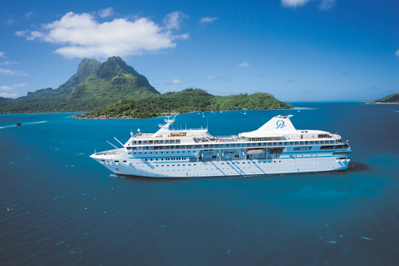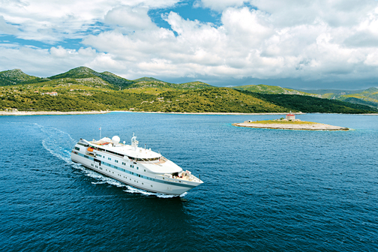

BELLEVUE, Wash. – December 17, 2013 – Paul Gauguin Cruises (www.pgcruises.com), operator of the highest-rated and longest continually sailing luxury cruise ship in the South Pacific, the m/s Paul Gauguin, and the 90-guest
m/v Tere Moana, is pleased to announce 2015 voyages, which feature a new 10-night Roundtrip Fiji itinerary on
The Gauguin and a new 7-night Roundtrip Venice itinerary on The Moana, along with popular favorites.

Paul Gauguin Cruises is extending savings of 50% off standard cruise fares on all 2015 voyages of both ships, plus included airfare from Los Angeles on m/s Paul Gauguin itineraries.

The Gauguin
New for 2015 on The Gauguin is a 10-night Roundtrip Fiji voyage visiting Lautoka, Fiji; lle des Pins, New Caledonia; Noumea, New Caledonia; IIe De Mare, New Caledonia; IIe Lifou, New Caledonia; Port Vila, Vanuatu; and Lautoka, Fiji, departing October 31, 2015, with cruise fares from $5,445 per person, including airfare from Los Angeles.

The Gauguin will also be featuring its most popular itineraries in 2015: the 7-night Tahiti & the Society Islands;
10-night Society Islands & Tuamotus; 11-night Cook Islands & Society Islands; and 14-night Marquesas, Tuamotus & Society Islands. Other highlights include 12- and 13-night Fiji, Tonga, Cook & Society Islands voyages.

The Moana
New for 2015 on The Moana is a 7-night Roundtrip Venice voyage with visits to the Croatian ports of Rovinj, Island SV Andrea, Hvar, Dubrovnik, Vis, Sibenick, and Split, departing August 1, 2015, with cruise fares from $3,995 per person. Other European itineraries The Moana will be offering include Athens, Greece, to Venice, Italy, and Istanbul, Turkey, to Athens, Greece.

The Moana will again sail the Caribbean and Latin America in the winter months. Highlights include Colón, Panama, to Philipsburg, St. Maarten voyages visiting: Cartagena, Colombia; Oranjestad, Aruba; and Les Saintes, F.W.I. The
8-night voyage also includes a visit to St. Barts, F.W.I., and departs March 20, 2015, with cruise fares from $3,495 per person. The December 12, 2015, departure is a 7-night reverse itinerary with cruise fares from $2,845 per person. Two transatlantic cruises are also available between Philipsburg, St. Maarten, and Lisbon, Portugal, a 14-night voyage departing April 4, 2015, with cruise fares from $2,095 per person, and a 13-night voyage departing November 29, 2015, with cruise fares from $1,945 per person.

In the Caribbean, The Moana offers a 7-night Roundtrip Philipsburg, St. Maarten, itinerary visiting: Tortola, B.V.I.; Jost Van Dyke, B.V.I.; Virgin Gorda, B.V.I.; Basseterre, St. Kitts & Nevis; Les Saintes, F.W.I.; and St. Barts, F.W.I., departing March 28, 2015, with cruise fares from $3,145 per person.

Also available on The Moana is a 7-night Colón, Panama, to Puerto Caldera, Costa Rica, voyage visiting: Portobelo, Panama; Panama Canal evening transit; Panama City, Panama; Isla de Coiba, Panama; Golfito, Costa Rica; Quepos, Costa Rica; and Isla Tortuga/Curú Wildlife Reserve, departing December 19, 2015, with cruise fares from $4,145 per person. The Moana’s 7-night Roundtrip Puerto Caldera, Costa Rica, voyage visits Isla Gamez, Panama, along with the Costa Rican ports of Golfito, Drake Bay, Isla del Caño, Quepos, and Isla Tortuga/Curú Wildlife Reserve, departing December 26, 2015, with cruise fares from $4,145 per person.

For rates or more information on Paul Gauguin Cruises, please contact a Travel Professional, call 800-848-6172, or visit www.pgcruises.com.

###
About Paul Gauguin Cruises
Owned by Pacific Beachcomber S.C., French Polynesia’s leading luxury hotel and cruise operator, Paul Gauguin Cruises operates the 5+-star cruise ship, the 332-guest m/s Paul Gauguin, providing a deluxe cruise experience tailored to the unparalleled wonders of Tahiti, French Polynesia, the South Pacific, and Southeast Asia. It is one of the top exclusive charter and incentive group venues in the industry and has completed more than 570 South Pacific cruises, serving more than 176,250 guests, including more than 15,000 honeymooners, since its inaugural sail in 1998. The Gauguin’s accolades include recognition as “Top Small-Ship Cruise Line for Families” in Travel + Leisure’s 2013 “World’s Best Awards” and one of the “Top 20 Small Cruise Ships” in 2013 for the 15th year in a row by readers of Condé Nast Traveler.

In December 2012, the m/v Tere Moana began sailing under the Paul Gauguin Cruises banner after completing a multifaceted renovation and offers voyages in the Caribbean, Latin America, and Europe. At 330 feet long and 46 feet wide, The Moana has a draft of 11.5 feet and accommodates 90 guests with a staff of 60.

Media Contact:
Paul Gauguin Cruises
Vanessa Bloy, Director of Public Relations
(425) 440-6255
vbloy@pgcruises.com

