
PAUL GAUGUIN CRUISES ANNOUNCES 2014 VOYAGES FEATURING NEW ITINERARIES AND PORTS
In Fiji, Australia, Southeast Asia, Europe, Latin America, and Costa Rica

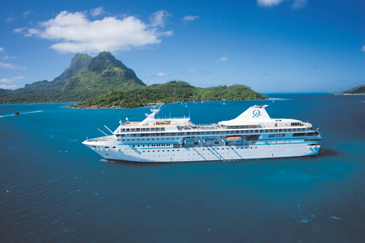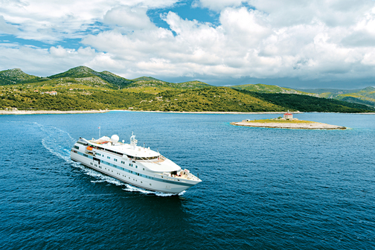

BELLEVUE, Wash. – February 13, 2013 – Paul Gauguin Cruises (www.pgcruises.com), operator of the highest-rated and longest continually sailing luxury cruise ship in the South Pacific, the m/s Paul Gauguin, and the m/v Tere Moana, is pleased to announce 2014 voyages featuring new itineraries and ports in Fiji, Australia, Southeast Asia, Europe, Latin America, and Costa Rica.

New for 2014 on The Gauguin:
- An 11-night Fiji to Australia voyage: Lautoka, Fiji; Port Vila, Vanuatu; Espiritu Santo, Vanuatu; Guadalcanal, Solomon Islands; Kieta, Bougainville, Papua New Guinea; Samurai Island, Papua New Guinea; Rabaul, Papua New Guinea; and Cairns, Australia. Departing June 14, 2014, with cruise fares from $5,995 per person, including airfare from Los Angeles.
- Two 14-night voyages between Australia & Southeast Asia: Cairns, Australia; Thursday Island, Australia; Darwin, Australia; Komodo Island, Indonesia; Benoa, Bali, Indonesia; Semarang, Indonesia; and Singapore. Departing June 25, 2014, with cruise fares from $7,395 per person, including airfare from Los Angeles. Reverse itinerary available August 4, 2014, with cruise fares from $7,095 per person, including airfare from Los Angeles.
- A 12-night Australia to Fiji voyage: Cairns, Australia; Samurai Island, Papua New Guinea; Rabul, Papua New Guinea; Kieta, Bougainville, Papua New Guinea; Guadalcanal, Solomon Islands; Espiritu Santo, Vanuatu; Port Vila, Vanuatu; Malolo Island, Fiji; and Lautoka, Fiji. Departing August 18, 2014, with cruise fares from $6,395 per person, including airfare from Los Angeles.
- New ports for The Gauguin include: Guadalcanal, Solomon Islands; Kieta, Bougainville, Papua New Guinea; Rabaul, Papua New Guinea; Samurai Island, Papua New Guinea; Thursday Island, Australia; Darwin, Australia; Komodo Island, Indonesia; Benoa, Bali, Indonesia; Semarang, Indonesia; Singapore; and Maupiti, Society Islands.

The Gauguin returns to Fiji in 2014 with 12- and 13-night Fiji, Tonga, Cook & Society Islands voyages and also offers four of its most popular itineraries: the 7-night Tahiti & the Society Islands; 10-night Society Islands & Tuamotus; 11-night Cook Islands & Society Islands; and 14-night Marquesas, Tuamotus & Society Islands.

New for 2014 on The Moana:
- A 7-night Latin America & Caribbean voyage: Colón, Panama; At Sea; Cartagena, Colombia; At Sea; Oranjestad, Aruba; At Sea; Les Saintes, F.W.I.; and St. Martin, F.W.I. Departing March 15, 2014, with cruise fares from $2,995 per person.
- Two 7-night Italy & the Amalfi Coast voyages: Rome (Civitavecchia), Italy; Amalfi, Italy; Sorrento, Italy; Lipari, Italy; Capri, Italy; Ponza, Italy; Golfito di Aranci, Italy; Porto-Vecchio, France; and Rome (Civitavecchia), Italy. Departing April 26, 2014, with cruise fares from $3,795 per person and September 13, 2014, with cruise fares from $3,995 per person.

- Four 7-night French & Italian Rivieras voyages: Rome (Civitavecchia), Italy; Elba (Portoferraio), Italy; Porto Venere, Italy; Florence (Livorno), Italy; Portofino, Italy; Monte Carlo, Monaco (overnight); Villefranche, France; and Nice, France. Departing June 28, 2014 with cruise fares from $3,995 per person, and August 9, 2014, with cruise fares from $3,795 per person. Reverse itinerary available July 5 and September 6, 2014, with cruise fares from $3,995 per person.
- A 7-night French Riviera voyage: Nice, France; Sanary-sur-Mer, France; St. Tropez, France; Antibes, France; Villefranche, France; Monte Carlo, Monaco (overnight); San Remo, Italy; and Nice, France. Departing August 30, 2014, with cruise fares from $3,995 per person.
- Four 7-night French Riviera & Spanish Isles voyages: Nice, France; Monte Carlo, Monaco; St. Tropez, France; Sète, France; Palamós, Spain; Mahón, Menorca, Spain; Palma de Mallorca, Spain; and Barcelona Spain. Departing August 16, 2014, with cruise fares from $3,795 per person and October 4, 2014, with cruise fares from $3,995 per person. Reverse itinerary available August 23, 2014, with cruise fares from $3,795 per person and September 27, 2014, with cruise fares from $3,995 per person.
- Three 7-night Costa Rica voyages: Puerto Caldera, Costa Rica; Isla Gamez, Panama; Golfito, Costa Rica; Drake Bay, Costa Rica; Isla del Caño, Costa Rica; Quepos, Costa Rica; Isla Tortuga/Curú Wildlife Reserve, Costa Rica; and Puerto Caldera, Costa Rica. Departing December 13, 2014, with cruise fares starting from $2,695 per person, and December 20, and 27, 2014, with cruise fares from $3,945 per person.
- New ports for The Moana include: Mahón, Menorca, Spain; Palamós, Spain; Villefranche, France; Sanary-sur-Mer, France; Antibes, France; Ponza, Italy; San Remo, Italy; San Blas, Panama; Isla Gamez, Panama; Golfito, Costa Rica; Drake Bay, Costa Rica; Quepos, Costa Rica; and Isla Tortuga/Curú Wildlife Reserve, Costa Rica.

In addition to its new itineraries in 2014, The Moana offers 7-night Latin America & Caribbean voyages and a 14-night Transatlantic cruise in March. From April through October, the ship operates 7-night sailings in Europe including: Italy & the Amalfi Coast; Italy, Greece, & the Dalmatian Coast; Italy, Greece & Croatia; Greek Isles; and Adriatic & Italy. And in November, a 14-night Transatlantic cruise along with a 14-night Panama Canal sailing are available.
Paul Gauguin Cruises is extending savings of 50% off standard cruise fares on all voyages of both ships, plus included airfare from Los Angeles on m/s Paul Gauguin itineraries. For rates or more information on Paul Gauguin Cruises, please contact a Travel Professional, call 800-848-6172, or visit www.pgcruises.com.

###
About Paul Gauguin Cruises
Owned by Pacific Beachcomber S.C., French Polynesia’s leading luxury hotel and cruise operator, Paul Gauguin Cruises operates the 5+-star cruise ship, the 332-guest m/s Paul Gauguin, providing a deluxe cruise experience tailored to the unparalleled wonders of Tahiti, French Polynesia, the South Pacific, and Southeast Asia. It is one of the top exclusive charter and incentive group venues in the industry and has completed more than 570 South Pacific cruises, serving more than 176,250 guests, including more than 15,000 honeymooners, since its inaugural sail in 1998. The Gauguin’s accolades include second place for small-ship cruise lines in Travel + Leisure’s 2012 “World’s Best Awards” and was recognized as one of the “Top 20 Small Cruise Ships” in 2013 for the 15th year in a row by readers of Condé Nast Traveler.

In December 2012, the m/v Tere Moana began sailing under the Paul Gauguin Cruises banner after completing a multifaceted renovation and offers voyages in the Caribbean, Latin America, and Europe. At 330 feet long and 46 feet wide, The Moana has a draft of 11.5 feet, and accommodates 90 guests with a staff of 60.

Media Contact:
Vanessa Bloy |Director of Public Relations | Paul Gauguin Cruises
(425) 440-6255|vbloy@pgcruises.com

