
m/s PAUL GAUGUIN ON CONDÉ NAST TRAVELER’S 2013 LIST OF “TOP 20 SMALL CRUISE SHIPS”
Voted by Readers in the Magazine’s Annual Poll of Top Cruise Ships of the World

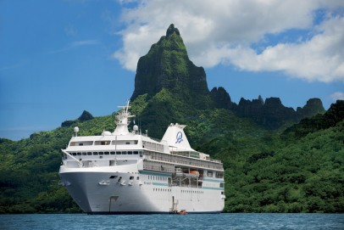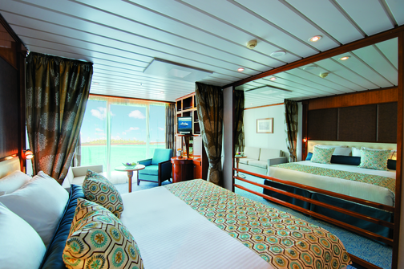

BELLEVUE, Wash. – January 23, 2013 – Paul Gauguin Cruises (www.pgcruises.com), operator of the highest-rated and longest continually sailing luxury cruise ship in the South Pacific, the m/s Paul Gauguin, is pleased to announce the selection of The Gauguin as one of the “Top 20 Small Cruise Ships” in 2013 by readers of Condé Nast Traveler magazine.

Readers rated cruise ships on a variety of criteria including itineraries/schedule, shore excursions, crew/service, cabins, food/dining, activities/facilities, and design/layout in the annual readers’ poll, which recognizes the “Top 100 Cruise Ships in the World.”

The full list of top cruise ships can be found on the magazine's website at www.cntraveler.com and is also featured in the February 2013 issue of Condé Nast Traveler.

Paul Gauguin Cruises’ commitment to providing guests with the most luxurious and enriching cruise vacations to Tahiti, French Polynesia, and the South Pacific has consistently placed The Gauguin on the esteemed Condé Nast Traveler list 15 years in a row.
For rates or more information on Paul Gauguin Cruises, please contact a Travel Professional, call 800-848-6172, or visit www.pgcruises.com.
###
About Paul Gauguin Cruises
Owned by Pacific Beachcomber S.C., French Polynesia’s leading luxury hotel and cruise operator, Paul Gauguin Cruises operates the 5+-star cruise ship, the 332-guest m/s Paul Gauguin, providing a deluxe cruise experience tailored to the unparalleled wonders of Tahiti, French Polynesia, and the South Pacific. It is one of the top exclusive charter and incentive group venues in the industry and has completed more than 570 South Pacific cruises, serving more than 176,250 guests, including more than 15,000 honeymooners, since its inaugural sail in 1998. The Gauguin’s 2012 accolades include a second place for small-ship cruise lines in Travel + Leisure’s “World’s Best Awards” and was recognized as one of the “Top 20 Small Cruise Ships” by readers of Condé Nast Traveler.

In December 2012, the m/v Tere Moana began sailing under the Paul Gauguin Cruises banner after completing a multifaceted renovation and offers voyages in the Caribbean, Latin America, and Europe. At 330 feet long and 46 feet wide, The Moana has a draft of 11.5 feet, and accommodates 88 guests with a staff of 64.

Media Contact:
Vanessa Bloy, Director of Public Relations,
Paul Gauguin Cruises
(425) 440-6255 / vbloy@pgcruises.com

