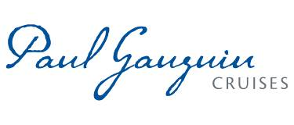
PAUL GAUGUIN CRUISES OFFERS EXCLUSIVE “TAKE YOUR SWEETIE TO TAHITI” VALENTINE’S GIFT PACKAGE
On Select 2017 and 2018 Sailings Booked Between January 30 and February 18, 2017

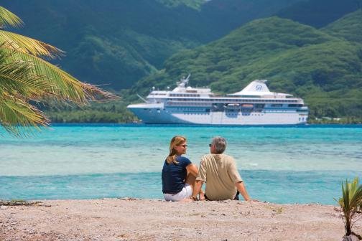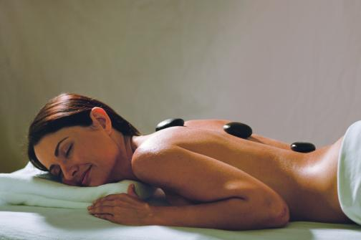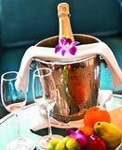

BELLEVUE, Wash. – January 30, 2017 – Paul Gauguin Cruises (www.pgcruises.com), operator of the highest-rated and longest continually sailing luxury cruise ship in the South Pacific, the m/s Paul Gauguin, is celebrating Valentine’s Day by offering an exclusive gift package to guests on select 2017 and 2018 sailings aboard The Gauguin who book between January 30 and February 18, 2017.

The Valentine’s gift package includes a $200 per-stateroom credit at the ship’s Deep Nature Spa by Algotherm, a box of chocolates, and a bottle of sparkling wine (total package valued at $250). The package is available on voyages departing August 26, 2017, through December 29, 2018, excluding the October 7, 2017, sailing. As with all 2017 and 2018 sailings aboard The Gauguin, guests also receive 50% off standard all-inclusive cruise fares and included roundtrip airfare from Los Angeles.

At the Deep Nature Spa by Algotherm, expert therapists and aestheticians offer an extensive menu of massages, skin care, facials, and authentic Polynesian treatments including Bora Bora Deep Blue Massages, Black Sand Body Scrubs, and Monoï Tradition Massages by Hei Poa, among a variety of other signature therapies and tropical treats.

Designed to sail the seas of the South Pacific, The Gauguin offers the perfect setting to celebrate a wedding, renewal of vows, anniversary—or simply each other. Couples can take in the beauty of the islands of French Polynesia from the privacy of their suite or stateroom, sway to the sounds of a chanteuse at La Palette Lounge, explore paradise on land excursions, dine al fresco under a starry sky, and enjoy a Polynesian blessing ceremony performed by members of Les Gauguines and Les Gauguins—the ship’s own troupe of Polynesian entertainers. With one of the highest crew-to-guest ratios at sea, The Gauguin is renowned for the extra touches and attention to detail that make every occasion special.

In addition, Paul Gauguin Cruises now offers wedding ceremony† and renewal of vows packages that allow couples sailing on The Gauguin to celebrate their love in a romantic setting amid the turquoise lagoons and exotic islands of French Polynesia. Choices include Motu Mahana, the cruise line’s private islet off the coast of Taha’a, and the luxurious InterContinental Bora Bora Resort & Thalasso Spa.

Paul Gauguin Cruises also has a Gift Registry, where guests celebrating their honeymoon, anniversary, or other milestone event can choose a “wish list” of gifts, ranging from shore excursions to spa options. Friends and family can visit the gift registry quickly and conveniently to select the gift (or gifts) they would like to give, and Paul Gauguin Cruises takes care of the rest.

For rates or more information on Paul Gauguin Cruises, please contact a Travel Professional, call 800-848-6172, or visit www.pgcruises.com.
###

*One Valentine’s Day gift package per booking. New bookings only. Please refer to promotion code: VALENTINES2017. Valid on sailing dates August 26, 2017, through December 29, 2018, excluding the October 7, 2017, sailing. Not combinable with Groups, Two-Week Sales, and other select reduced-rate offers. May or may not be combined with other Shipboard Credit offers. Complimentary sparkling wine upon embarkation only. Offer expires February 18, 2017. Call for details.

†Wedding ceremony is not legally binding.

About Paul Gauguin Cruises
Owned by Pacific Beachcomber S.C., French Polynesia’s leading luxury hotel and cruise operator, Paul Gauguin Cruises operates the 5+-star cruise ship, the 332-guest m/s Paul Gauguin, providing a deluxe cruise experience tailored to the unparalleled wonders of Tahiti, French Polynesia, Fiji, and the South Pacific. Paul Gauguin Cruises accolades include being voted #2 in the category of “Top Small Cruise Lines” in the Condé Nast Traveler 2016 Readers’ Choice Awards and recognition on the publication’s 2016 “Gold List.” Recently, readers voted Paul Gauguin Cruises “#1 Midsize-Ship Ocean Cruise Line” in the Travel + Leisure World’s Best Awards 2016.‡
Media Contact:
Paul Gauguin Cruises
Vanessa Bloy, Director of Public Relations
(425) 440-6255
vbloy@pgcruises.com

‡From Travel + Leisure, August 2016 ©2016 Time Inc. Affluent Media Group. Used under license. Travel + Leisure and Time Inc. Affluent Media Group are not affiliated with, and do not endorse products or services of Paul Gauguin Cruises.

