
PAUL GAUGUIN CRUISES OFFERS EXCLUSIVE “TAKE YOUR SWEETIE TO TAHITI” VALENTINE’S GIFT PACKAGE
on all m/s Paul Gauguin 2013 Sailings Booked Between February 4 and February 16, 2013

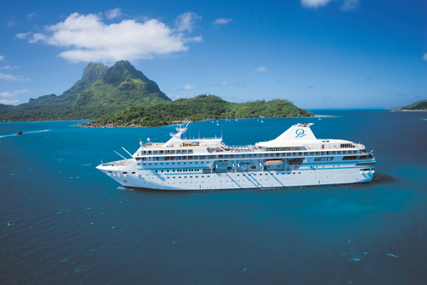

BELLEVUE, Wash. – February 4, 2013 – Paul Gauguin Cruises (www.pgcruises.com), operator of the highest-rated and longest continually sailing luxury cruise ship in the South Pacific, the m/s Paul Gauguin, is celebrating Valentine’s Day by offering an exclusive gift package to guests who book any 2013 sailing aboard The Gauguin between February 4 and February 16, 2013.

The Valentine’s Gift Package includes a $200 per-stateroom credit at the ship’s Deep Nature Spa by Algotherm, a box of Godiva chocolates, and flower turndown service (a $230 value). As with all 2013 sailings aboard The Gauguin, guests also receive 50% off standard all-inclusive cruise fares and included airfare from Los Angeles.

At the Deep Nature Spa by Algotherm, expert therapists and aestheticians offer an extensive menu of massages, skin care, facials, and authentic Polynesian treatments including Monoï Tradition Massages by Hei Poa, Bora Bora Deep Blue Massages, and Black Sand Body Scrubs, among a variety of other signature therapies and tropical treats.

Designed to sail the seas of the South Pacific, The Gauguin offers the perfect setting to celebrate a wedding, renewal of vows, anniversary—or simply each other. Couples can take in the beauty of the islands of French Polynesia from the privacy of their suite or stateroom, sway to the sounds of a chanteuse at La Palette Lounge, explore paradise on land excursions, dine al fresco under a starry sky, and enjoy a Polynesian blessing ceremony performed by Les Gauguines—the ship’s own troupe of Polynesian entertainers. With one of the highest crew-to-guest ratios at sea, The Gauguin is renowned for the extra touches and attention to detail that make every occasion special.

Paul Gauguin Cruises also offers a Gift Registry, where guests celebrating their honeymoon, anniversary, or other milestone event can choose a “wish list” of gifts, ranging from shore excursions to spa options. Friends and family can visit the gift registry quickly and conveniently to select the gift (or gifts) they would like to give, and Paul Gauguin Cruises takes care of the rest.

For rates or more information on Paul Gauguin Cruises, please contact a Travel Professional, call 800-848-6172, or visit www.pgcruises.com.
*One Valentine’s Day gift package per booking. New bookings only. Please refer to promotion code: VALENTINES. Not combinable with groups, two-week sales, and other select reduced-rate offers. Flower turndown service available on first night of sailing only. Offer expires February 16, 2013. Call for details.
###

About Paul Gauguin Cruises
Owned by Pacific Beachcomber S.C., French Polynesia’s leading luxury hotel and cruise operator, Paul Gauguin Cruises operates the 5+-star cruise ship, the 332-guest m/s Paul Gauguin, providing a deluxe cruise experience tailored to the unparalleled wonders of Tahiti, French Polynesia, and the South Pacific. It is one of the top exclusive charter and incentive group venues in the industry and has completed more than 570 South Pacific cruises, serving more than 176,250 guests, including more than 15,000 honeymooners, since its inaugural sail in 1998. The Gauguin’s accolades include second place for small-ship cruise lines in Travel + Leisure’s 2012 “World’s Best Awards” and was recognized as one of the “Top 20 Small Cruise Ships” in 2013 for the 15th year in a row by readers of Condé Nast Traveler.

In December 2012, the m/v Tere Moana began sailing under the Paul Gauguin Cruises banner after completing a multifaceted renovation and offers voyages in the Caribbean, Latin America, and Europe. At 330 feet long and 46 feet wide, The Moana has a draft of 11.5 feet, and accommodates 88 guests with a staff of 64.

Media Contact:
Vanessa Bloy, Director of Public Relations,
Paul Gauguin Cruises
(425) 440-6255 / vbloy@pgcruises.com

