

**PAUL GAUGUIN CRUISES OFFERS A TWO-WEEK SALE**

**ON SELECT TAHITI, FRENCH POLYNESIA, AND SOUTH PACIFIC VOYAGES**

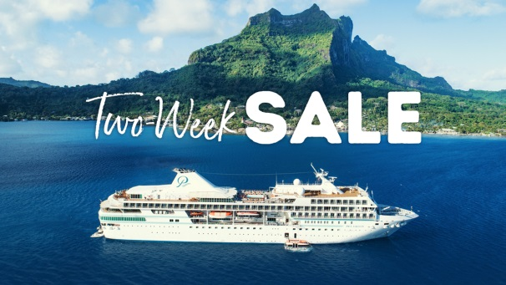

**BELLEVUE, WASH. – June 24, 2020** – **Paul Gauguin Cruises** ([www.pgcruises.com](http://www.pgcruises.com)), operator of the highest-rated and longest continually sailing luxury cruise ship in the South Pacific, the m/s *Paul Gauguin*, announces a [Two-Week Sale](https://www.pgcruises.com/promotions/two-week-sale) on select **Tahiti, French Polynesia, and South Pacific** voyages.

Paul Gauguin Cruises is offering **savings of up to $3,050* per person** off select voyages aboard *The Gauguin* when booked by July 8, 2020.Roundtrip airfare between Los Angeles and Papeete, Tahiti, is also included. Additionally, deposits on these sailings have been reduced to $250 per person. On board, guests will enjoy the highest standards of luxury, quality, and all-inclusive value sailing to South Pacific destinations that are the cruise line’s specialty. Qualifying voyages are:

***[Tahiti & the Society Islands](https://www.pgcruises.com/promotions/two-week-sale)* [(7 nights):](https://www.pgcruises.com/promotions/two-week-sale)**

* September 12, 2020–now from only ~~$6,245~~ $5,295 per person
* September 19, 2020–now from only ~~$6,245~~ $5,295 per person

***[Society Islands & Tahiti Iti](https://www.pgcruises.com/promotions/two-week-sale)* [(7 nights):](https://www.pgcruises.com/promotions/two-week-sale)**

* August 22, 2020–now from only ~~$6,395~~ $5,295 per person
* September 26, 2020–now from only ~~$6,245~~ $5,295 per person
* December 19, 2020–now from only ~~$5,795~~ $5,295 per person

***[Society Islands & Tuamotus](https://www.pgcruises.com/promotions/two-week-sale)* [(10 nights):](https://www.pgcruises.com/promotions/two-week-sale)**

* November 11, 2020–now from only ~~$6,495~~ $5,695 per person

On *The Gauguin,* nearly 70% of suites and staterooms offer balconies. Dining experiences include L’Etoile, which showcases an array of culinary creations expertly prepared each evening. The ship’s other two dining venues, La Veranda and Le Grill, serve breakfast and lunch. At night, signature dishes designed by French celebrity chef Jean-Pierre Vigato are offered in La Veranda, and Polynesian specialties are served poolside at Le Grill.

Les Gauguines and Les Gauguins—the ship’s exclusive troupe of Tahitian entertainers—provide enriching experiences of the destinations throughout each voyage. *The Gauguin* features expert lecturers on each voyage, and special guests on select sailings conduct presentations on topics ranging from the history of the South Pacific to conservation, culture, marine life, and the wonders of coral reefs.

One of the highlights of each sailing is exclusive access to Motu Mahana, the cruise line’s private islet off the coast of Taha’a, where guests can enjoy sunbathing, swimming, snorkeling, kayaking, Polynesian activities, a full-service bar, and a delicious barbecue. In Bora Bora, guests can enjoy complimentary access to a private, white-sand beach with beach volleyball, sunbathing, snorkeling, and paddleboarding.

Paul Gauguin Cruises “Covid-Safe Protocol” manifesto is available online [here](https://www.calameo.com/read/000132423bdb3b0a1a579?authid=k4a19tLoX9rj).

For more information or reservations, contact a professional travel advisor, call 1-800-848-6172, or visit [www.pgcruises.com](http://www.pgcruises.com).

###

*\*All fares are in US dollars, per person, based on double occupancy, and reflect promotional savings, are for new bookings only, are subject to availability, and must be booked by July 8, 2020. Included roundtrip airfare from Los Angeles applies to first and second guest in a stateroom only. Offer may be combined with applicable 3rd guest in stateroom offer but may not be combinable with other offers. Port, security, and handling charges of $159-$215 per person are additional. Additional terms and conditions may apply. Call for details.*

**About Paul Gauguin Cruises**

Paul Gauguin Cruises operates the luxury cruise ship, the m/s *Paul Gauguin*, providing a deluxe cruise experience tailored to the unparalleled wonders of Tahiti, French Polynesia, and the South Pacific. Paul Gauguin Cruises has been recognized by notable publications in travel and lifestyle and was voted “#1 Midsize-Ship Ocean Cruise Line” by readers in the *Travel + Leisure* World’s Best Awards 2019. The line was recognized as one of the “Top Small Cruise Lines” in the *Condé Nast Traveler* 2019 Readers’ Choice Awards and is honored on the publication’s 2018 “Gold List.” Paul Gauguin Cruises was selected as “Best Small-Ship Cruise Line” in *Global Traveler’s* Leisure Lifestyle Awards from 2016 to 2019, and has received top honors in *BRIDES* Magazine’s Honeymoon Awards for the past three years. And recently the line was recognized for the third time for having the “Best French Polynesia Cruises” in the [*AFAR* Travelers’ Choice Awards](https://www.afar.com/magazine/travelers-choice-awards-2019). In September 2019, Paul Gauguin Cruises joined PONANT’s family, the world leader of small ship cruising.

**Media Contact:**

Vanessa Bloy

Paul Gauguin Cruises

Director of Public Relations

(425) 440-6255

[vbloy@pgcruises.com](mailto:vbloy@pgcruises.com)