
PAUL GAUGUIN CRUISES OFFERS EXCLUSIVE 2-WEEK SALE ON TAHITI & THE SOCIETY ISLANDS SAILINGS

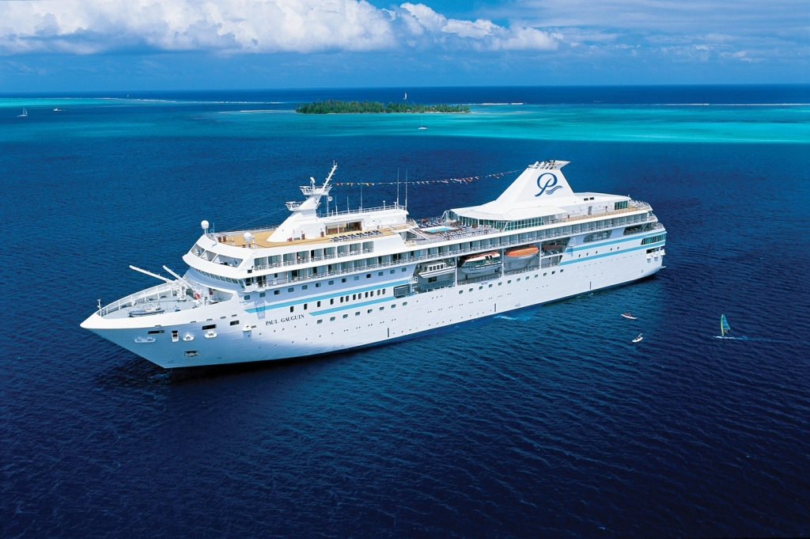

MEDIA ALERT: For two weeks only, Paul Gauguin Cruises, operator of the highest-rated and longest continually sailing luxury cruise ship in the South Pacific, the m/s Paul Gauguin, is offering incredible savings on select sailings of its most popular voyage, Tahiti & the Society Islands. Guests will benefit from these exceptional savings while enjoying the highest standards of luxury, quality and service in the most exquisite destination in the world.

Sale: Book select sailings aboard the seven-night Tahiti & the Society Islands voyage and save $800 to $2,500 per person off previously advertised prices in addition to the 50% off standard cruise fare. Plus, guests receive FREE airfare from Los Angeles. Must be booked by March 10, 2012.*

Tahiti & the Society Islands
7-night voyages: June 2, 9, 16, 23, 2012;
Now from only $4,597 $3,797 per person

7-night voyages: July 21, 28; August 4, 11, 2012;
Now from only $4,697 $3,897 per person

CONTACT: For reservations, contact a professional travel agent, call 1-800-848-6172, or visit www.pgcruises.com.

###
About Paul Gauguin Cruises
Owned by Pacific Beachcomber S.C., French Polynesia’s leading luxury hotel and cruise operator, Paul Gauguin Cruises operates the 5+-star cruise ship m/s Paul Gauguin, providing a deluxe cruise experience tailored to the unparalleled wonders of Tahiti, French Polynesia, and the South Pacific. The Gauguin was built at the Chantiers de l’Atlantique shipyard in Saint Nazaire, France. The ship, 513 feet long and 71 feet wide, has a draft of 16.9 feet and can accommodate 332 guests with a staff of 217. It is one of the top Exclusive Charter and Incentive Group venues in the industry and has completed more than 570 South Pacific cruises, serving more than 176,250 guests, including more than 15,000 honeymooners, since its inaugural sail in 1998. The Gauguin has undergone more than $25 million in enhancements, with an additional $7 million completed in January 2012. The Gauguin has been impressively named the 2011 Silver Magellan Award Winner in the Small Cruise Ship category by Travel Weekly and earned the “#1 ranking for Dining” in the Small Ship Category in Cruise Critic’s 2011 Cruisers’ Choice Awards.

Paul Gauguin Cruises also recently announced the acquisition of a second ship, which will begin sailing under the Paul Gauguin Cruises banner in December 2012. With plans to sail to Europe, the Caribbean, and Latin America, this ship will be christened m/v Tere Moana after completing a multifaceted renovation in December 2012. The Moana features 45 staterooms accommodating 90 guests.

For additional information on Paul Gauguin Cruises, please visit www.pgcruises.com.

Media Contact:
Paul Gauguin Cruises
Vanessa Bloy, Director of Public Relations
(425) 440-6255
vbloy@pgcruises.com

*Select sailings and new bookings only. Offer may be combined with free 3rd guest in stateroom offer and 5% past guest savings. Offer expires March 10, 2012. Call for details. Prices shown reflect savings.

