
PAUL GAUGUIN CRUISES OFFERS EXCLUSIVE 2-WEEK SALE ON TAHITI & THE SOCIETY ISLANDS SAILINGS

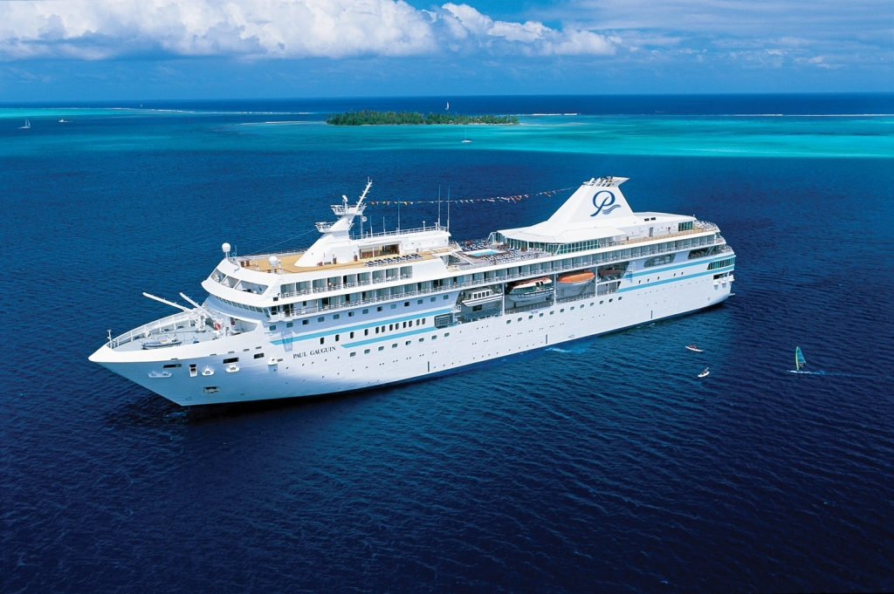

MEDIA ALERT: For two weeks only, Paul Gauguin Cruises, operator of the highest-rated and longest continually sailing luxury cruise ship in the South Pacific, the m/s Paul Gauguin, is offering incredible savings on select sailings of its most popular voyage, Tahiti & the Society Islands, when booked between May 7 and May 19, 2012. Guests will benefit from these exceptional savings while enjoying the highest standards of luxury, quality, and service in the most exquisite destination in the world.

Sale: Book select sailings aboard the seven-night Tahiti & the Society Islands voyage and save $700 to $2,500 per person off previously advertised prices in addition to the 50% off standard cruise fare.* Plus, guests receive FREE airfare from Los Angeles.

Tahiti & the Society Islands
7-night voyages: July 21, 28; August 4, 11; December 22, 29, 2012
Now from only $4,697 $3,897 per person

7-night voyage: October 6, 13, 2012
Now from only $4,597 $3,797 per person

7-night voyage: December 15, 2012
Now from only $4,297 $3,597 per person

7-night voyage: January 5, 2013
Now from only $4,495 $3,597 per person

CONTACT: For reservations, contact a professional travel agent, call 1-800-848-6172, or visit www.pgcruises.com.
###

About Paul Gauguin Cruises
Owned by Pacific Beachcomber S.C., French Polynesia’s leading luxury hotel and cruise operator, Paul Gauguin Cruises operates the 5+-star cruise ship m/s Paul Gauguin, providing a deluxe cruise experience tailored to the unparalleled wonders of Tahiti, French Polynesia, and the South Pacific. The Gauguin was built at the Chantiers de l’Atlantique shipyard in Saint Nazaire, France. The ship, 513 feet long and 71 feet wide, has a draft of 16.9 feet, and can accommodate 332 guests with a staff of 217. It is one of the top Exclusive Charter and Incentive Group venues in the industry and has completed more than 570 South Pacific cruises, serving more than 176,250 guests, including more than 15,000 honeymooners, since its inaugural sail in 1998. The Gauguin has undergone more than $25 million in enhancements, with an additional $7 million completed in January 2012. The Gauguin has been impressively named the 2011 Silver Magellan Award Winner in the Small Cruise Ship category by Travel Weekly and was recognized as one of the “Top 20 Small Cruise Ships” by readers of Condé Nast Traveler in 2012.

The cruise line’s second ship, the m/v Tere Moana, will begin sailing under the Paul Gauguin Cruises’ banner in December 2012 after completing a multifaceted renovation. The ship, which will sail Europe, the Caribbean, and Latin America, is 330 feet long and 46 feet wide, has a draft of 11.5 feet, and can accommodate 90 guests with a staff of 54.

For additional information on Paul Gauguin Cruises, please visit www.pgcruises.com.
Media Contact:
Paul Gauguin Cruises
Vanessa Bloy, Director of Public Relations
(425) 440-6255
vbloy@pgcruises.com

*Select sailings and new bookings only. Offer may be combined with free 3rd guest in stateroom offer and 5% past guest savings. Offer expires May 19, 2012. Call for details. Prices shown reflect savings. Government fees and taxes of $14 per person for 2012 departures and $89 per person for the 2013 departure are not included. For full terms and conditions visit www.pgcruises.com.

