
PAUL GAUGUIN CRUISES OFFERS EXCLUSIVE 2-WEEK SALE ON SELECT 2013 SAILINGS
IN TAHITI, FRENCH POLYNESIA & THE SOUTH PACIFIC

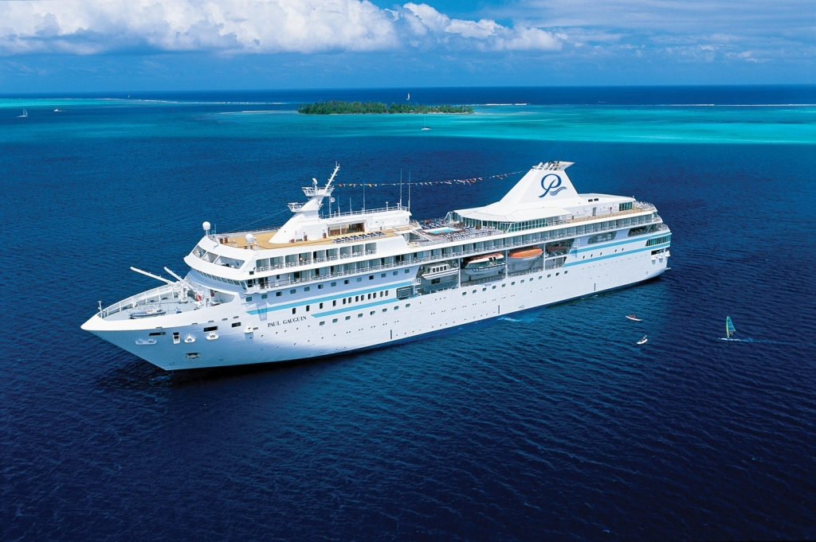

MEDIA ALERT: For two weeks only, Paul Gauguin Cruises, operator of the highest-rated and longest continually sailing luxury cruise ship in the South Pacific, the m/s Paul Gauguin, is offering incredible savings on select 2013 voyages in Tahiti, French Polynesia & the South Pacific when booked between October 15 and 27, 2012. Guests will benefit from exceptional savings of $800 to $4,300 per person off previously advertised rates while enjoying the highest standards of luxury, quality, and service in one of the most exquisite destinations in the world.

Sale: Book select sailings on the 7-night Tahiti & the Society Islands, the 11-night Cook Islands & Society Islands, or the 14-night Marquesas, Tuamotus & Society Islands and save $800 to $4,300 per person in addition to 50% off standard cruise fare and included airfare from Los Angeles.

Tahiti & the Society Islands  7-night voyages: March 2, 9, 2013  Now from only $4,495 $3,695 per person  7-night voyage: May 4, 2013  Now from only $4,595 $3,795 per person | Cook Islands & Society Islands  11-night voyage: January 12, 2013  Now from only $5,195 $4,245 per person  11-night voyage: March 16, 2013  Now from only $5,395 $4,395 per person | Marquesas, Tuamotus & Society Islands  14-night voyage: February 2, 2013  Now from only $6,245 $4,995 per person

CONTACT: For reservations, contact a professional travel agent, call 1-800-848-6172, or visit www.pgcruises.com.
###
About Paul Gauguin Cruises
Owned by Pacific Beachcomber S.C., French Polynesia’s leading luxury hotel and cruise operator, Paul Gauguin Cruises operates the 5+-star cruise ship m/s Paul Gauguin, providing a deluxe cruise experience tailored to the unparalleled wonders of Tahiti, French Polynesia, and the South Pacific. The Gauguin was built at the Chantiers de l’Atlantique shipyard in Saint Nazaire, France. The ship, 513 feet long and 71 feet wide, has a draft of 16.9 feet, and can accommodate 332 guests with a staff of 217. It is one of the top Exclusive Charter and Incentive Group venues in the industry and has completed more than 570 South Pacific cruises, serving more than 176,250 guests, including more than 15,000 honeymooners, since its inaugural sail in 1998. The Gauguin has undergone more than $25 million in enhancements, with an additional $7 million completed in January 2012. The Gauguin received second place for small-ship cruise lines in Travel + Leisure’s “2012 World’s Best Awards” and was recognized as one of the “Top 20 Small Cruise Ships” by readers of Condé Nast Traveler in 2012.

The cruise line’s second ship, the m/v Tere Moana, will begin sailing under the Paul Gauguin Cruises banner in December 2012 after completing a multifaceted renovation. The ship, which will sail Europe, the Caribbean, and Latin America, is 330 feet long and 46 feet wide, has a draft of 11.5 feet, and can accommodate 90 guests with a staff of 60.

Media Contact:
Paul Gauguin Cruises
Vanessa Bloy, Director of Public Relations
(425) 440-6255
vbloy@pgcruises.com

*Select sailings and new bookings only. Available only while space lasts. Offer may be combined with free 3rd guest in stateroom offer and 5% past guest savings. Offer expires October 27, 2012. Prices shown reflect savings. Government fees and taxes of $89-$178 per person for 2013 departures are not included. Call for details. For full terms and conditions visit www.pgcruises.com.

